Database Design Document: PeerGrid
1. Introduction
This document details the database design for the PeerGrid platform. The design is a relational database model using PostgreSQL. It is structured to efficiently support all core functionalities, including user management, college directory, reviews, community features, alumni networking, and the AI-driven recommendation system.
The design follows normalization principles to minimize data redundancy and ensure data integrity, while strategic indexing is incorporated for query performance.
2. Database Schema: Entity-Relationship Diagram (ERD)
The core entities and their primary relationships are illustrated below:
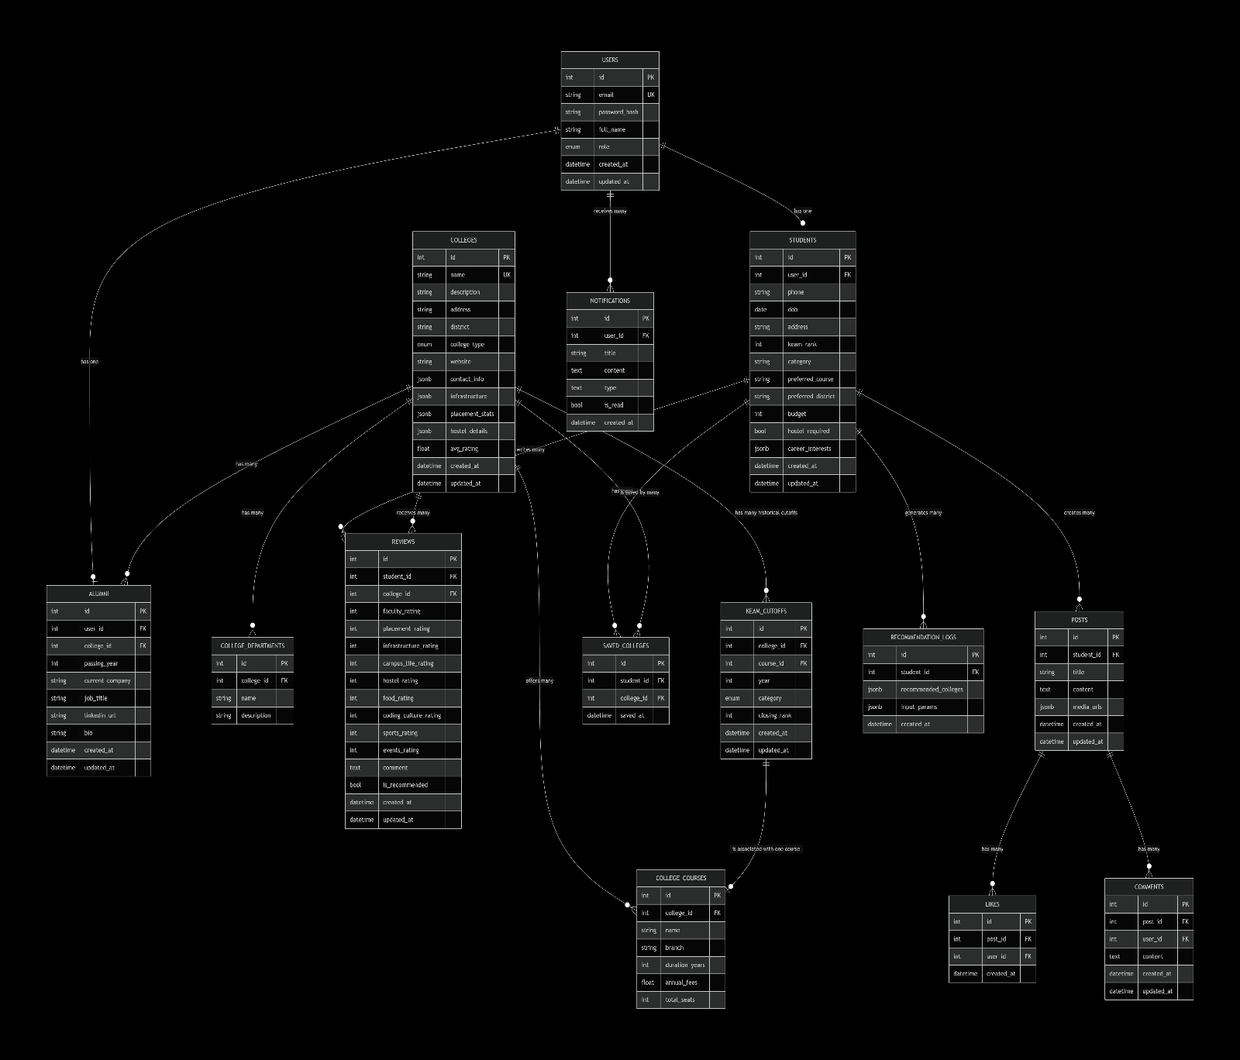
3. Detailed Table Definitions
3.1 users (Core User Table)
- Purpose: Stores authentication and basic profile information for all users (Students, Alumni, Admin).
- Key Fields:
  - id: SERIAL PRIMARY KEY
  - email: VARCHAR(255) UNIQUE NOT NULL
  - password_hash: VARCHAR(255) NOT NULL (for JWT authentication)
  - full_name: VARCHAR(255) NOT NULL
  - role: user_role ENUM ('student', 'alumni', 'admin') DEFAULT 'student'
  - is_active: BOOLEAN DEFAULT TRUE
  - created_at: TIMESTAMP WITH TIME ZONE DEFAULT CURRENT_TIMESTAMP
  - updated_at: TIMESTAMP WITH TIME ZONE DEFAULT CURRENT_TIMESTAMP

3.2 students
- Purpose: Stores detailed profile data specific to students.
- Key Fields:
  - id: SERIAL PRIMARY KEY
  - user_id: INTEGER UNIQUE REFERENCES users(id) ON DELETE CASCADE
  - phone: VARCHAR(20)
  - dob: DATE
  - address: TEXT
  - keam_rank: INTEGER
  - category: VARCHAR(50) (e.g., 'General', 'OBC', 'SC/ST')
  - preferred_course: VARCHAR(255) (e.g., 'B.Tech')
  - preferred_district: VARCHAR(100)
  - budget: INTEGER (Annual budget in INR)
  - hostel_required: BOOLEAN DEFAULT FALSE
  - career_interests: JSONB (Stores a list of interests like 'Software Development', 'Data Science', 'Design')
  - created_at: TIMESTAMP WITH TIME ZONE DEFAULT CURRENT_TIMESTAMP
  - updated_at: TIMESTAMP WITH TIME ZONE DEFAULT CURRENT_TIMESTAMP
3.3 alumni
- Purpose: Stores professional and association data for alumni.
- Key Fields:
  - id: SERIAL PRIMARY KEY
  - user_id: INTEGER UNIQUE REFERENCES users(id) ON DELETE CASCADE
  - college_id: INTEGER REFERENCES colleges(id) ON DELETE SET NULL
  - passing_year: INTEGER
  - current_company: VARCHAR(255)
  - job_title: VARCHAR(255)
  - linkedin_url: VARCHAR(255)
  - bio: TEXT
  - created_at: TIMESTAMP WITH TIME ZONE DEFAULT CURRENT_TIMESTAMP
  - updated_at: TIMESTAMP WITH TIME ZONE DEFAULT CURRENT_TIMESTAMP

3.4 colleges
- Purpose: The central repository for all college information.
- Key Fields:
  - id: SERIAL PRIMARY KEY
  - name: VARCHAR(255) UNIQUE NOT NULL
  - description: TEXT
  - address: TEXT
  - district: VARCHAR(100) NOT NULL
  - college_type: college_type ENUM ('government', 'private', 'aided')
  - website: VARCHAR(255)
  - contact_info: JSONB (Store phone, email, etc.)
  - infrastructure: JSONB (Store facilities like labs, library, wifi, etc. as key-value pairs)
  - placement_stats: JSONB (Store average package, highest package, top recruiters, etc.)
  - hostel_details: JSONB (Store capacity, fees, facilities)
  - avg_rating: FLOAT DEFAULT 0
  - is_verified: BOOLEAN DEFAULT FALSE
  - created_at: TIMESTAMP WITH TIME ZONE DEFAULT CURRENT_TIMESTAMP
  - updated_at: TIMESTAMP WITH TIME ZONE DEFAULT CURRENT_TIMESTAMP
3.5 college_departments
- Purpose: To store the various academic departments of a college.
- Key Fields:
  - id: SERIAL PRIMARY KEY
  - college_id: INTEGER REFERENCES colleges(id) ON DELETE CASCADE
  - name: VARCHAR(255) NOT NULL
  - description: TEXT
  - created_at: TIMESTAMP WITH TIME ZONE DEFAULT CURRENT_TIMESTAMP

3.6 college_courses
- Purpose: To store the specific courses (with branches) offered by a college. This is crucial for the recommendation system.
- Key Fields:
  - id: SERIAL PRIMARY KEY
  - college_id: INTEGER REFERENCES colleges(id) ON DELETE CASCADE
  - name: VARCHAR(255) NOT NULL (e.g., 'B.Tech')
  - branch: VARCHAR(255) NOT NULL (e.g., 'Computer Science')
  - duration_years: INTEGER
  - annual_fees: FLOAT
  - total_seats: INTEGER
  - created_at: TIMESTAMP WITH TIME ZONE DEFAULT CURRENT_TIMESTAMP
  - updated_at: TIMESTAMP WITH TIME ZONE DEFAULT CURRENT_TIMESTAMP
  - Constraint: A unique constraint on (college_id, name, branch)
3.7 reviews
- Purpose: Stores student-generated reviews and ratings for colleges.
- Key Fields:
  - id: SERIAL PRIMARY KEY
  - student_id: INTEGER REFERENCES students(id) ON DELETE CASCADE
  - college_id: INTEGER REFERENCES colleges(id) ON DELETE CASCADE
  - faculty_rating: INTEGER CHECK (1 <= rating <= 5)
  - placement_rating: INTEGER CHECK (1 <= rating <= 5)
  - infrastructure_rating: INTEGER CHECK (1 <= rating <= 5)
  - campus_life_rating: INTEGER CHECK (1 <= rating <= 5)
  - hostel_rating: INTEGER CHECK (1 <= rating <= 5)
  - food_rating: INTEGER CHECK (1 <= rating <= 5)
  - coding_culture_rating: INTEGER CHECK (1 <= rating <= 5)
  - sports_rating: INTEGER CHECK (1 <= rating <= 5)
  - events_rating: INTEGER CHECK (1 <= rating <= 5)
  - comment: TEXT
  - is_recommended: BOOLEAN
  - created_at: TIMESTAMP WITH TIME ZONE DEFAULT CURRENT_TIMESTAMP
  - updated_at: TIMESTAMP WITH TIME ZONE DEFAULT CURRENT_TIMESTAMP
  - Constraint: A unique constraint on (student_id, college_id) to prevent duplicate reviews from the same student.
3.8 posts (Community)
- Purpose: Stores community posts created by students.
- Key Fields:
  - id: SERIAL PRIMARY KEY
  - student_id: INTEGER REFERENCES students(id) ON DELETE CASCADE
  - title: VARCHAR(255) NOT NULL
  - content: TEXT NOT NULL
  - media_urls: JSONB (Stores an array of URLs for images/videos)
  - created_at: TIMESTAMP WITH TIME ZONE DEFAULT CURRENT_TIMESTAMP
  - updated_at: TIMESTAMP WITH TIME ZONE DEFAULT CURRENT_TIMESTAMP

3.9 comments
- Purpose: Stores comments on community posts.
- Key Fields:
  - id: SERIAL PRIMARY KEY
  - post_id: INTEGER REFERENCES posts(id) ON DELETE CASCADE
  - user_id: INTEGER REFERENCES users(id) ON DELETE CASCADE
  - content: TEXT NOT NULL
  - created_at: TIMESTAMP WITH TIME ZONE DEFAULT CURRENT_TIMESTAMP
  - updated_at: TIMESTAMP WITH TIME ZONE DEFAULT CURRENT_TIMESTAMP
3.10 likes
- Purpose: Tracks user likes on community posts.
- Key Fields:
  - id: SERIAL PRIMARY KEY
  - post_id: INTEGER REFERENCES posts(id) ON DELETE CASCADE
  - user_id: INTEGER REFERENCES users(id) ON DELETE CASCADE
  - created_at: TIMESTAMP WITH TIME ZONE DEFAULT CURRENT_TIMESTAMP
  - Constraint: A unique constraint on (post_id, user_id) to prevent duplicate likes.
3.11 saved_colleges
- Purpose: Manages the student's shortlist/bookmarks for colleges.
- Key Fields:
  - id: SERIAL PRIMARY KEY
  - student_id: INTEGER REFERENCES students(id) ON DELETE CASCADE
  - college_id: INTEGER REFERENCES colleges(id) ON DELETE CASCADE
  - saved_at: TIMESTAMP WITH TIME ZONE DEFAULT CURRENT_TIMESTAMP
  - Constraint: A unique constraint on (student_id, college_id).
3.12 keam_cutoffs
- Purpose: Stores historical KEAM allotment and cut-off data.
- Key Fields:
  - id: SERIAL PRIMARY KEY
  - college_id: INTEGER REFERENCES colleges(id) ON DELETE CASCADE
  - course_id: INTEGER REFERENCES college_courses(id) ON DELETE CASCADE
  - year: INTEGER NOT NULL
  - category: VARCHAR(50) NOT NULL
  - closing_rank: INTEGER NOT NULL
  - created_at: TIMESTAMP WITH TIME ZONE DEFAULT CURRENT_TIMESTAMP
  - updated_at: TIMESTAMP WITH TIME ZONE DEFAULT CURRENT_TIMESTAMP
  - Constraint: A unique constraint on (college_id, course_id, year, category).
3.13 recommendation_logs
- Purpose: Logs the results and inputs for recommendations generated for students. Used for auditing, analysis, and future model training.
- Key Fields:
  - id: SERIAL PRIMARY KEY
  - student_id: INTEGER REFERENCES students(id) ON DELETE CASCADE
  - recommended_colleges: JSONB (An ordered list of college IDs with their probability/chance scores)
  - input_params: JSONB (Snapshot of the student's profile and preferences used for the recommendation)
  - created_at: TIMESTAMP WITH TIME ZONE DEFAULT CURRENT_TIMESTAMP

3.14 notifications
- Purpose: Stores user-specific notifications.
- Key Fields:
  - id: SERIAL PRIMARY KEY
  - user_id: INTEGER REFERENCES users(id) ON DELETE CASCADE
  - title: VARCHAR(255) NOT NULL
  - content: TEXT NOT NULL
  - type: VARCHAR(50) (e.g., 'comment', 'reply', 'event', 'system')
  - is_read: BOOLEAN DEFAULT FALSE
  - created_at: TIMESTAMP WITH TIME ZONE DEFAULT CURRENT_TIMESTAMP

4. Indexing Strategy
To ensure optimal performance, the following indexes are recommended:
- Foreign Keys: Index all foreign key columns (e.g., user_id, college_id, post_id).
- users: email (for fast login lookups).
- colleges: district, college_type, avg_rating (for search and filtering).
- college_courses: branch (for filtering).
- keam_cutoffs: (college_id, course_id), (year), (category), (closing_rank) for analytical queries.
- reviews: (college_id, created_at) for fetching recent reviews for a college.
- posts: (student_id, created_at) for fetching a user's posts or timeline feeds.
- recommendation_logs: (student_id, created_at) for fetching a student's recommendation history.
5. Data Types & Considerations
- JSONB: Chosen over JSON for its indexing capabilities and efficient querying of nested data, which is beneficial for fields like infrastructure, career_interests, and media_urls.
- ENUM: Used for role, college_type to enforce data integrity and improve readability, as they represent a fixed set of possible values.
- TIMESTAMP WITH TIME ZONE: Used for all temporal fields to store timestamp in UTC, ensuring consistency across different user timezones.
6. How the Design Supports the Recommendation Engine
The recommendation engine relies heavily on the data stored in the following tables:
- students: Provides the input profile (rank, course, budget, etc.).
- colleges & college_courses: Provides details about the options available.
- keam_cutoffs: Provides the historical data to predict admission probability based on rank and category.
- reviews: Provides qualitative and quantitative sentiment data on campus life, placements, etc., allowing the ML model to incorporate student satisfaction scores as features.
- recommendation_logs: This table is critical for the ML pipeline. It allows you to log every recommendation request and its results. This data can be used to build a training dataset, analyze the effectiveness of the model, and continuously improve it (e.g., by correlating recommended colleges with future actions like saving or applying).

